

5/12/17

Version 1

Finance

Procedure Manual

©2017 Conduent State Healthcare, LLC. All rights reserved. CONDUENT® and the CONDUENT design are trademarks of CONDUENT Marketing LP in the United States and/or other countries. Conduent® and Conduent and Design® are trademarks of Conduent Corporation in the United States and/or other countries.

# Revision History

(The revision history is used to track changes and updates made to procedures and when they occurred. This must be completed every time an update or revision to the document is made)

| **Version** | **Major Section being changed** | **Sub section and page**  **being changed** | **Date of change** | **Description of change** | **Author** |
| --- | --- | --- | --- | --- | --- |
| 0001 | Entire Document | Entire document | 03/18/14 | Update to new procedures template. | S. Montaño |
| 1.0 | Check Printing Sections |  | 10/2014 | Revision to warrant template | S. Montano |
|  | Entire Document | Entire Document | 5/12/17 | Rebranding to Conduent | S. Montano |
|  |  |  |  |  |  |
|  |  |  |  |  |  |
|  |  |  |  |  |  |
|  |  |  |  |  |  |
|  |  |  |  |  |  |
|  |  |  |  |  |  |
|  |  |  |  |  |  |
|  |  |  |  |  |  |
|  |  |  |  |  |  |
|  |  |  |  |  |  |
|  |  |  |  |  |  |
|  |  |  |  |  |  |
|  |  |  |  |  |  |
|  |  |  |  |  |  |
|  |  |  |  |  |  |
|  |  |  |  |  |  |
|  |  |  |  |  |  |
|  |  |  |  |  |  |
|  |  |  |  |  |  |
|  |  |  |  |  |  |
|  |  |  |  |  |  |
|  |  |  |  |  |  |
|  |  |  |  |  |  |
|  |  |  |  |  |  |
|  |  |  |  |  |  |

# Table of Contents

Revision History ii

Table of Contents iii

Introduction: 1

Service Level Agreements (SLAs) 1

Security and Confidentiality 2

Staffing 3

Departmental Duties 4

Quality Assurance 4

Tools: 5

Procedures 6

# Activity #1: Review Checkwrite Balancing 6

# Activity #2: Print and Sign Warrants 8

# Activity #3: Special Handling of Warrants 11

# Activity #4: Inserting Warrants and Remittance Advices 12

# Activity #5: Transmitting Check Receipts to ASD/HSD 14

# Activity #6: Prepare Refund/Return Documentation 19

Activity #7: Entering Refund Checks Into Omnicaid  21

# Activity #8: Stop Payment – Stale Dated Warrants 24

# Activity #9: Stop Payment-Void Mutilated Warrant 26

# Activity #10: Void Warrant-Mass Adjustment 28

# Activity #11: Entering Payout Transactions Into Omnicaid 30

# Activity #12: Advance Payments 34

# Activity #13: Gross Level Receivable 37

# Activity #14: Receivable Transfer 40

# Activity #15: Receivable Reversal 42

# Activity #16: Reissue Warrant 44

# Activity #17: Receivable Refund From Provider 47

# Activity #18: Prepare Void Adjustment Batches 48

# Activity #19: Securing Postage For Client Mailings 50

Appendix: 52

# Introduction:

The Finance Department is responsible for the manual activities associated with financial and payment processing. The unit processes incoming checks, enters financial transactions and prepares transmittals of checks and supporting documentation for submission to HSD.

## Service Level Agreements (SLAs)

|  |
| --- |
| Finance |
| 19.3.1.6 Perform, at a minimum, the following functions related to paper warrant production:  19.3.1.6.1 Provide, maintain and operate the hardware and software necessary to print warrants on blank laser check stock rather than pre-printed warrant stock, using secure laser printers equipped with signature cards and special toner.  19.3.1.6.2 Maintain sufficient stock of toner and blank security stock for normal production requirements.  19.3.1.6.3 Exercise controls over blank stock storage, warrant generation and warrant distribution to prevent any fraud or other improper loss or redemption and to ensure timely and accurate delivery to providers.  19.3.1.6.4 Maintain a check hold log of those providers who are determined by the Procuring Agency to be out of cost report compliance, have had a change of ownership, have had a voluntary closure, are subject to liens and court orders, or are out of compliance with Medicaid policies and procedures.  19.3.1.6.4.1 Update the MMIS system list that prevents such providers from receiving payment via EFT and forces a paper warrant to be generated.  19.3.1.6.4.2 Provide procedures to prevent such warrants from being mailed or otherwise given to the provider when requested by the Procuring Agency for the payment to be held.  19.3.1.6.4.3 Manually remove such warrants from those prepared to be mailed and securely store them at the Procuring Agency's request. The CONTRACTOR shall void or make warrants payable to the State or other entities, (e.g. Internal Revenue Service) as instructed by the Procuring Agency.  19.3.1.7 Process provider refund checks.  19.3.1.8 Process adjustments and voids related to provider refunds.  19.3.1.9 Balance the weekly check write amounts.  19.3.1.10 Process returned and voided warrants.  19.3.1.11 Process manual advance check requests from the Procuring Agency.  19.3.1.12 Communicate with the Procuring Agency and with the State Treasury Office regarding voided warrants, re-issued warrants, and other warrant issues. |
| 21.2.6 Entering Transactions into MMIS as Directed by the State - The CONTRACTOR is responsible for entering financial transactions (accounts receivable, payouts and receipts) into the MMIS as directed by the Procuring Agency.  21.2.7 Limit Access to the Provider File - CONTRACTOR personnel who have financial transaction privileges must be prohibited from updating the Provider File. |

## Security and Confidentiality

*Please refer to the Security manual (link)*

## 

# Staffing

Finance Unit Lead

Financial Specialist

Financial Clerk

# Departmental Duties

Processes include:

* Print and Prepare State Warrants for Distribution
* Receive and Process Provider Refund Checks
* Process Returned, Lost and Voided Warrants
* Process Payouts and Recoupments
* Process Manual and System Advances
* Initiate Process of Voids and Adjustments Related to Provider Refunds
* Enter Financial Transactions
* Administer check hold processes

## Quality Assurance

*Any specific QA measurements are listed here. (i.e. call monitoring)*

## 

# Tools:

* Omnicaid
* Intraviewer
* Workflow
* Shared drive forms

# **Activity #1:**

# Review Checkwrite Balancing:

Description / Purpose

Each Monday morning the Financial Unit, in coordination with technical staff in Atlanta and Albuquerque assigned to the Omnicaid financial system, reviews the balancing of the previous weeks checkwrite reports. Checkwrite balancing is an automated process and, as such, systems staff are primarily responsible for this function. The checkwrite reports are a summary of all claim and financial activity processed the previous week. The Financial Unit must be certain all reports balance. The following procedures describe the balancing and reporting process to the Administrative Services Division of the Human Services Department (ASD/HSD).

Each week Conduent is required to balance the checkwrite reports to ensure that cash outlays authorized by the state for data represented in these reports is correct. Any anomalies within or between reports must be analyzed, explained and, if necessary, corrected. Occasionally an uncommon adjustment transaction may mistakenly create the appearance of or an actual “out of balance” situation. Technical staff must address and resolve these and follow through the PLOG process to prevent a recurrence.

Steps

### Procedure 1: Receive Reports from Remote Job Entry (RJE) Unit

#### Financial Unit Lead

1. Receive the following reports from RJE Unit..

NMMC5000 – Weekly ADHOC Balancing

RC040 - Accounts Receivable Aging Summary

RC045 - Final Payment Summary

RC046 - Final MMIS Payment Register – first and last two pages

RC047 - Financial Transaction Summary

RC049 - Negative Balance Detail Report

RC051 - Preliminary Payment Summary

RC053 - Remittance Activity Control Totals

RC055 - Suspended A/R Balance Report

RC057 - Recovery Suspense Report

RC058 - Refund Deposit and Voided Check Summary Report

RC059 - Check Register Summary Report

RC064 - Fiscal Payment Summary Report

RF001 - Front End Consolidation Report

RF002 - Non-State Institution Summary

RF003 - State Institution Summary

RF004 - New Mexico Medicaid Benefits

RF005 - Expense Distribution Summary – Weekly

RF006 - Cancel Stop Staledate Report – Weekly

1. Verify you have received (via Intraviewer) all of the reports listed above.
2. If any reports are missing, advise the RJE Unit Lead and request the reports be provided . If you encounter a further problem accessing the reports, notify the Financial Unit Manager. Reports are to be available no later than 7:00am each Monday morning.

### Procedure 2: Balance checkwrite reports

###### Financial Unit Lead

1. The NMMC5000 ADHOC BALANCE REPORT is automatically generated and used to balance payment reports.
2. The balance report will verify the total of claims and financial payments processed through OmniCaid for the previous week are equal to the total dollar amount of warrants issued.
3. The totals will automatically be entered in the “Balance Verification” section at the bottom of the report. If all the figures are the same, the checkwrite balances.
4. If the checkwrite is not in balance the report will show “OUT OF BALANCE”. Systems staff are required to address this condition and, if possible, resolve the balancing problem.
5. If the checkwrite remains out-of-balance, notify the Financial Manager or the Deputy Account Manager in Albuquerque. The Account Manager in Albuquerque and the Systems Manager in Atlanta must be notified if the matter cannot be resolved. The Systems Manager will designate an individual to review the checkwrite and provide an explanation and resolution of the out-of-balance condition.
6. If the out of balance is not corrected by 9:00am notify ASD of the situation. Advise ASD again when the out of balance is resolved. See Procedure 8 below for phone number.
7. Prepare a photocopy of the first page and the last two pages of the RC046. Apply the warrant information attachment to the last page of the report. Enter the range of spoiled, manual and system generated warrants, the warrant number range and the micr-encoded range of warrant numbers.
8. Send, by courier, one copy of all reports and Balance Sheet to the current designated employee at ASD. If Monday is a holiday these should be faxed. The fax number for ASD in Santa Fe is 505-827-8103.
9. Send one copy of all reports to the current designated employee at ASD via Conduent courier.

# 

# **Activity #2:**

# Print and Sign Warrants:

Description / Purpose

Conduent is required to print and sign warrants for non-EFT (Electronic Fund Transfer) providers using data produced each week during the weekend check write cycle. Warrant printing and signing must be monitored carefully and the process also must ensure dual control over the inventory of blank warrant stock and signature storage device. Warrants are stored in a room secured with a standard latch lock and a deadbolt system. Walls extending above the ceiling surround the room and there is no false ceiling. Keys are controlled by staff (referred to as Observers below) who are not part of the Financial Unit. This adds extra security and protection for the blank warrant stock which needs to be tracked by document number. Signature devices are kept in a safe within another secured room, also controlled by non Financial staff and different from Observers described above. Warrant printing must be monitored closely to ensure that the data printed on the warrants is accurate and legible, especially to automated bank MICR readers.

Steps

### Procedure 1: Removing Blank Warrants From Secure Storage

#### Financial Unit Lead (or Financial Manager) and Financial Specialist and Observer (not from Financial Department)

1. The range of warrant numbers to be printed is determined from the final MMIS PAYMENT REGISTER (RC046) by noting the first and last warrant number.
2. The Financial Unit Lead, Financial Specialist and the Observer work together to witness that only the necessary quantity of warrants needed to print the week’s (or replacement) warrants are removed from the secured storage.
3. Complete the WARRANT STOCK CONTROL LOG (Figure 1) by recording the “from” and “through” range of warrant serial numbers shown on the back side of the warrant. Both must sign the log verifying the warrants removed.
4. Two staff members will escort the blank warrant stock to the Financial Unit where laser printing will occur.

## Figure 1

## WARRANT STOCK CONTROL LOG

|  |  |  |  |  |
| --- | --- | --- | --- | --- |
| **Date** | **Signature 2 Required** | **Number of Warrants** | **FROM** | **TO** |
|  |  |  |  |  |
|  |  |  |  |  |
|  |  |  |  |  |
|  |  |  |  |  |
|  |  |  |  |  |
|  |  |  |  |  |
|  |  |  |  |  |

Procedure 2: Printing Warrants

**Financial Unit lead (or Financial Manager) and Financial Specialist**

1. Warrants are printed in the Financial Unit. Warrant printing can be performed only by staff trained on the EZPAY Manager software. The local IT Support Administrator is also trained on the warrant printing process and can be called upon to assist with any technical issue related to warrant printing.
2. The weekly data for check printing must be downloaded from the web-based DMZ/GrabIt server where it has been uploaded by the Atlanta System Maintenance Team. Only specific personnel are granted access to this file on the DMZ website, as designated by the Atlanta team. The data is accessible only for a limited period of time and can be restored to the website only by the Atlanta team.
3. Before warrants can be printed, staff will need to acquire the signature and template storage device, which is a flash drive kept in the safe in the Financial Unit and controlled by the QA Manager or his/her designee. The device is inserted into the module attached to the MICR (Magnetic Ink Character Recognition) printing enabled laser printer, also located in the Financial Unit. *[Update: 10/9/14 - Currently undergoing process to shift file storage to new secure EZPay Server, including contents of flash drive. Due to security protocols, any changes to logos or official DFA signature appearing on warrants must be made to the file on this server and will require local IT Support Administrator assistance in coordination with EZPay software vendor.]*
4. Using dedicated hardware, trained staff will place the data in the proper folder within the EZPay Manager software where it will be processed by the software and prepared for printing.
5. After properly loading the blank check stock in the trays of the special MICR printing enabled laser printers (face up, head in first), the check printing can begin. If any warrants are damaged before or during the process, replacement warrant(s) can be obtained, following the controlled process in Procedure #1, steps 2 through 4, and reprinted as allowed by the software. Damaged documents need to be retained for serial number tracking.
6. During printing, output should periodically be examined for accuracy and quality.
7. When printing is complete the signature and template storage device is returned to the safe by the QA Manager or his/her designee. *[Null after completion of update described in step #3]*
8. Printed warrants should not be removed from the secure location in the Financial Unit until they are ready for mailing.

**NOTE: WARRANTS WILL BE UNDER THE CONTROL OF THE FINANCIAL UNIT UNTIL NOTIFICATION FROM ASD/HSD IS RECEIVED THAT WARRANTS MAY BE RELEASED. WARRANTS WILL NOT BE RELEASED TO ANYONE UNDER ANY CIRCUMSTANCE UNTIL OFFICIAL NOTIFICATION OR SPECIFIC DIRECTION IS RECEIVED.**

# **Activity #3:**

# Special Handling of Warrants:

Description / Purpose

As a matter of policy Conduent does not allow distribution of paper warrants other than by first class mail on days specified for release. Doing so would remove one of the incentives for providers to sign up for payments by EFT (Electronic Funds Transfer). Conduent may, however, in special cases or circumstances, receive specific instructions from the state on behalf of providers requesting to receive their warrant by other than U.S. mail. Options may be to send the warrant by express delivery (Fed Ex, UPS etc.) typically using the provider’s express service account number, or the provider may wish to call for the warrant at the Conduent office in Albuquerque. To accommodate these state approved special requests the Finance Unit must pull the warrants from sequence and prepare the warrant as requested.

Steps

Procedure 1: Pull Warrants From Sequence

**Financial Specialist**

1. Pull warrants from the sequence of warrants according to the written directive from the state for those providers who have been approved for special handling.
2. Prepare the warrant for pick-up:
3. If using express delivery; obtain provider’s express vendor account number and prepare appropriate shipping labels and envelopes and package the warrant. Deliver to front desk for pick-up by the express company. A call will likely be needed to notify the express company of the package for pick up.
4. If provider will be coming to the Conduent Albuquerque office for pick up; prepare provider pick up sheet which the provider’s designee for pick up must sign. That person must also present identification to match the name previously designated in the correspondence concerning these arrangements.

# **Activity #4:**

# Inserting Warrants and Remittance Advices:

Description / Purpose

This process will be followed only if Conduent is unable to utilize Electronic Fund Transfer of provider payments and/or access to electronic version of remittance advices (RA) on provider web portal is not available.

Warrants and remittance advices (RA) are matched as needed, inserted into envelopes and mailed to providers. Controls are in place to ensure all warrants are inserted correctly. If more than one staff member is required for this task, warrants will be entered on a log identifying the warrants assigned to each staff member assisting with and responsible for inserting. Counts will be taken to guarantee all warrants are inserted and returned to the Financial Specialist supervising the process .

Steps

Procedure 1: Preparing Warrants for Insertion

**Financial Specialist**

1. Separate warrants in batches of one hundred.
2. If printed, separate remittance advices in stacks matching the range of warrants.
3. Place the warrants with the corresponding batch of remittance advices.
4. As warrants and remittance advices are distributed to the staff, record the range of warrant numbers assigned to that staff member on a colored sheet which will be signed by the staff member working that batch and filed along with the other documents in the weekly file.
5. Instruct the staff to keep the envelopes in either ascending or descending warrant number order as they are being inserted. It may be necessary to retrieve a warrant after warrants have been stuffed.
6. Continue this process with each staff member until the insertion process is completed. After insertion process is complete, place the warrants in the secured warrant room.

Procedure 2: Release warrants for Distribution

**Financial Manager**

1. Receive notification from the state (ASD/HSD) that warrants are released. This means the state has secured the funds to cover the dollar amount of warrants after which the warrants may be mailed/distributed. ASD WILL NOTIFY CONDUENT BY A TELEPHONE CALL AND/OR A FAX .
2. Notify the Financial Unit Lead that warrants are released and may be delivered to Document Control mailroom. The Mail Room will apply postage and store the envelopes until they are picked up by the U.S. Postal Service.

Procedure 3: Release Special Handled Warrants

**Financial Specialist**

1. Warrants held for special handling may be distributed per instructions previously discussed.

**NOTE: WARRANTS WILL BE UNDER THE CONTROL OF THE FINANCIAL UNIT UNTIL NOTIFICATION FROM ASD IS RECEIVED THAT WARRANTS MAY BE RELEASED. WARRANTS WILL NOT BE RELEASED TO ANYONE UNDER ANY CIRCUMSTANCE UNTIL OFFICIAL NOTIFICATION OR SPECIFIC DIRECTION IS RECEIVED.**

# **Activity #5:**

# Transmitting Check Receipts to ASD/HSD:

Description / Purpose

Providers may receive payments they should not keep. They may have billed a claim in error, received a financial payment in error, or they may have also received payment from another insurance company. In these cases, the provider is required to refund the Medicaid program for these payments.

Steps

Procedure 1: Receive Checks from Mailroom

**Financial Specialist**

1. The Financial Unit receives a DAILY CHECK LOG (Figure 1, on next page) of refund checks and supporting documentation from the mailroom.
2. Compare checks to the transmittal log to be certain you have received all checks. If any checks are missing, contact the Document Control Unit Lead.
3. Retain each log for future reference. This becomes a continuous log of all checks received each day

Figure 1

**DAILY CHECK LOG**

DATE:____________________________________________

|  |  |  |
| --- | --- | --- |
| **MARKER** | **CHECK #** | **CHECK $** |
|  |  |  |
|  |  |  |
|  |  |  |
|  |  |  |
|  |  |  |
|  |  |  |
|  |  |  |
|  |  |  |
|  |  |  |
|  |  |  |

Procedure 2: Prepare Checks for Transmittal to ASD

**Financial Specialist**

1. Review all checks and documentation to determine a reason for the refund. If you are unable to determine a reason, place the check in a “Contact Provider” file. A REQUEST FOR ADDITIONAL INFORMATION (Figure 2, on next page) letter is mailed to the provider along with a copy of the check to determine the reason for the refund. Enter TPL refunds on a separate log (discussed in #2 below). A copy of the TPL log is sent to the state’s TPL Unit as instructed later in this activity. Place endorsement stamp on the back of each check.

Figure 2 - REQUEST FOR ADDITIONAL INFORMATION

CSD

Dear Provider:

In order to process Medicaid refunds, several pieces of information are required to process them correctly. If all the required information is not included with the refund check, the Financial Unit at Conduent might inadvertently apply the refund to the wrong claim.

The minimum information required is the New Mexico provider number, the recipient’s ID number, and the dates of service. The preferred information includes the transaction control number (TCN) of the claim, amount billed, amount paid, date paid and reason for refund. Also, please include a copy of the page of the Remittance Advice (RA) with claim payment information.

The refund you sent in either did not have any or enough information for us to process correctly, so the refund will not be processed until we receive the required information. ***We have enclosed an Adjustment/Void Request (AVR) form. Please retain the original of this form to use as a master copy. In the future, always complete an AVR form for each claim that is included in the refund.***

Filling out the AVR and including a copy of the RA, ensures your refunds will be processed accurately, and will avoid future re-identification of these claims for recoupment. Should this occur, per state directive, it will be the provider’s responsibility to provide evidence that the overpayment on the claim has already been refunded. If you have any questions regarding this letter, please call me at (505) 246-9988 ext. 8131151.

Please mail requested information and a copy of this letter to:

Conduent

Financial Unit

1720-A Randolph Rd., S.E.

Albuquerque, N.M. 87106

Sincerely,

Financial Unit

Conduent

1. Log checks on the REFUND CHECK TRANSMITTAL LOG (Figure 3) as follows:
   * Enter today’s date
   * Enter page number.
   * Enter the check number
   * Enter the payer (the provider who wrote the check)
   * Enter the check amount
   * Enter the check date

Figure 3

**CONDUENT REFUND CHECK TRANSMITTAL LOG**

**TO: HSD/ASD**

**Attention: (HSD Employee) Date: __________ Page ___of___**

**On the above date Conduent received the checks listed below and is forwarding them to you for deposit.**

|  |  |  |  |  |  |  |
| --- | --- | --- | --- | --- | --- | --- |
| **Check #** | **Payer** | **Amount** | **Check Date** | **FCN** | **HSD #** | **Comment** |
|  |  |  |  |  |  |  |
|  |  |  |  |  |  |  |
|  |  |  |  |  |  |  |
|  |  |  |  |  |  |  |
|  |  |  |  |  |  |  |
|  |  |  |  |  |  |  |
|  |  |  |  |  |  |  |
|  | **Page total** | **99999999** |  |  |  |  |
|  | **Grand total** | **99999999** |  |  |  |  |

**BY SIGNING BELOW, THE PREPARER AND REVIEWER CERTIFY THE CHECKS ARE SUBMITTED TIMELY AS REQUIRED.**

**PREPARED BY_____________________________________ DATE____________**

**REVIEWED BY_____________________________________ DATE____________**

**HSD USE ONLY: STATE TREASURER RECEIPT #_____________ DATE_________ BY_______________DATE_______**

Procedure 2: Continued..

1. Add the check amount column and enter the sum in the PAGE TOTAL and GRAND TOTAL (for all pages) spaces. Total the check amounts and verify that the totals balance. If they do not balance, review and recalculate.
2. Make two copies of the completed REFUND CHECK TRANSMITAL LOG (Figure 3). One copy with the supporting documentation will be retained in the Financial Unit.
3. Send the original log with the checks in a sealed envelope to the Human Services Department to the HSD employee indicated on the log.

Current Name:_Xxxxx_Xxxxxxx___________________

ASD Accounting Bureau, Control Section

Human Services Department

Plaza San Miguel

729 St Michaels

Santa Fe, New Mexico

Send one copy of the log (TPL only) to:

Program Administration Bureau

Human Services Department

Medical Assistance Division

Santa Fe, New Mexico

The checks and logs will be transported by the Conduent courier.

# **Activity #6:**

# Prepare Refund/Return Documentation:

Description / Purpose

After refund checks have been forwarded to ASD, the transactions are prepared for entry into OmniCaid by completing a Refund/Return Reason Sheet, to document why checks have been submitted. The reason sheet provides the information to enter the transaction into OmniCaid.

Steps

Procedure 1: Preparing the Refund/Return Reason Sheet

**Financial Specialist**

1. A REFUND RETURN REASON SHEET (Figure 1, on next page) is prepared for each check sent by a provider or insurance company.
2. Review the documentation attached to the check copy to determine the following information:
   * Provider name
   * Provider number
   * Reason for return
   * TCN identifying the claim to be voided/adjusted.
3. If the check was received from a source other than a provider (i.e. an insurance carrier or recipient), review the attachments and use the name and ID number of the provider who was originally paid.
4. Enter the provider name in the space provided.
5. Enter the provider ID number in the space provided

Figure 1

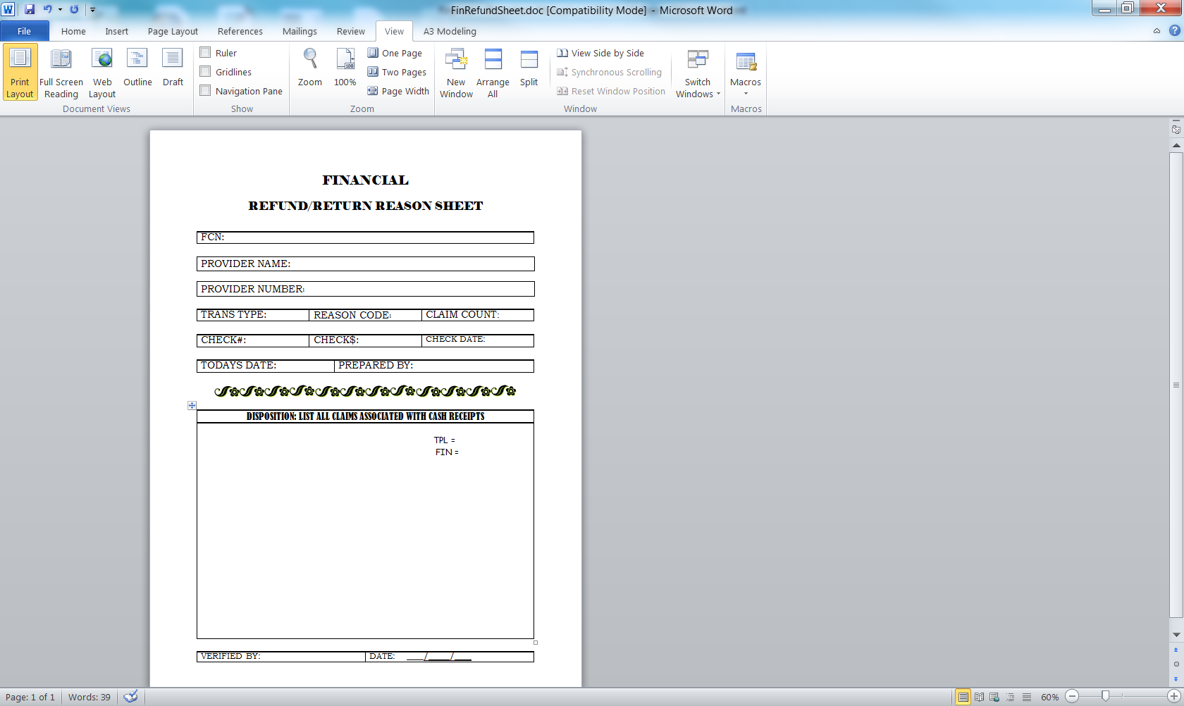

1. Do not enter FCN at this time.
2. Enter a “2” in the “Transaction Type” space for all refunds.
3. If you cannot determine the reason for the refund from the attached documentation or if no documentation was sent with the check, perform one of the following:
   * If the refund is from a provider, try calling the provider to obtain the information. If that fails, send a REQUEST FOR ADDITIONAL INFORMATION (See Activity #5 - Transmitting Check Receipts to ASD/HSD, Figure 2) with a copy of the check.
   * If the refund is from a source other than a provider, check with TPL to see if the refund is for that unit.
   * If the check is for TPL, enter into OmniCaid the same as other refunds except indicate TPL (Activity #7). The TPL Unit will prepare the adjustment or void in the TPL system and follow through with the disposition process.
4. Enter the number of claims to be adjusted or voided in the Claim Count space. If this information cannot be determined, or if the check is to be dispositioned at a gross level rather than against individual claims, leave this space blank.
5. Enter the check number, check amount and date of check in the space provided.
6. Sign and date the form at the bottom of the page.
7. Attach the REFUND/RETURN REASON SHEET (Figure 1) to the check copy and related documentation.
8. File the refunds requiring additional information in a file specified for that activity. This information should not be added to OmniCaid until all necessary information is available
9. If you receive a TPL refund, a copy of the check and documentation is forwarded to the TPL Unit for research. The TPL Unit will complete the REFUND/RETURN REASON SHEET (Figure 1) and return to the Financial Unit.

# **Activity #7:**

# Entering Refund Checks Into Omnicaid:

Description / Purpose

The Financial Receipt Selection window is used to search the OmniCaid database for a receipt transaction or a list of receipts that meet specified selection criteria, or to add a new receipt. The user can select a financial receipt by provider number. The purpose of this activity is to add a new receipt.

Steps

Procedure 1: Enter Refunds

**Financial Specialist**

1. From the OmniCaid main screen, click or place cursor on CONTROL PANEL and select FINANCIAL. Place the cursor and click on RECEIPT. You are now in the Financial Receipt Selection window.

Figure 1

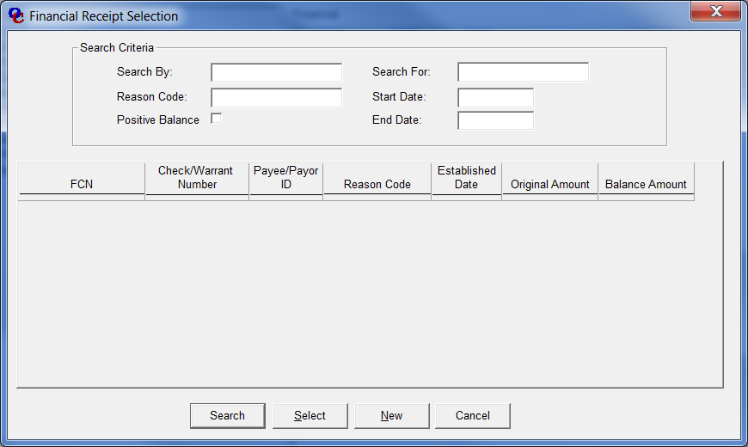

1. In the Search By drop down-box, select Provider ID and enter the provider ID in the Search For box. Select the appropriate reason code from the drop-down list and then click on NEW.
2. OmniCaid takes you to the FINANCIAL RECEIPT window (Figure 2), ORGINAL TAB, and assigns a FINANCIAL CONTROL NUMBER (FCN) shown at top. The provider ID and the provider name are automatically updated by OmniCaid. Record the FCN on the Adjustment/Void Reason Sheet. The FCN will be used later when entering adjustments or voids.
3. In the RECEIPT, ORIGINAL TAB window, the user enters the check or warrant amount, the check or warrant number and the deposit number. These fields are required. If you enter a warrant (a check originally issued by Conduent), the amount you enter must match the warrant amount in the OmniCaid system. OmniCaid populates the Established Date field with the date you create the receipt. During the process the user may change the REASON CODE, the AMOUNT and the CHECK or WARRANT NUMBER. These fields can be changed until the next payment cycle is run.
4. If all additions and modifications are complete and you wish to view on another Tab, choose FILE, then SAVE or use the SAVE icon on the tool bar.
5. If your entry is complete and you wish to submit the entry, then click on the X icon on the TOOLBAR or the X icon in the right hand corner of the window.
6. Clicking an X will result in a confirmation window. Click the YES button to save the data and close the window. Click NO to cancel entry of all data in this session and leave the window open. Click CANCEL to cancel the save and closure and continue keying data or making changes to the data.
7. Continue entering receipts.

Figure 2

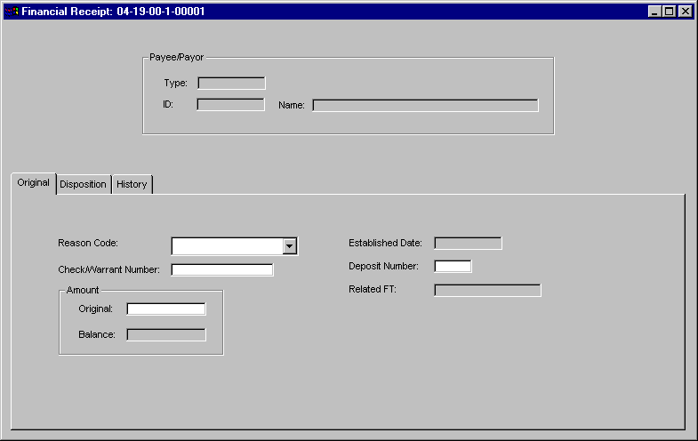

# **Activity #8:**

# Stop Payment – Stale Dated Warrants:

Description / Purpose

A stop payment may be placed on a warrant because the warrant is too old and became stale dated.

(Note: Due to federal requirement, HSD currently issues monthly directives to stale date all unredeemed warrants over six months old and void all claims associated with those warrants. The State has issued Stop Payment orders on these warrants and they cannot be reissued. Providers must resubmit all related claims in order to be paid. Original claim submission serves as proof of timely filing.)

Subject to the above, if Conduent is contacted by a provider stating they did not receive a warrant and the warrant is more than one year old or if the provider contacts Conduent and states they have the warrant in their possession but it is more than one year old, the provider must complete a Lost Check Affidavit, with notarization of the provider’s signature. (Again, this assumes it is somehow still a live warrant). See Activity #16.

Steps

Procedure 1: Stop Payment On A Stale Dated Warrant

**Financial Lead or Specialist**

1. Receive list from HSD requesting warrant(s) over 6 months old be stale dated in OMNICAID. (NOTE: Federal requirement overrides language on warrant that says VOID ONE YEAR FROM DATE.) *[Update 10/9/14 – Currently updating warrant template to show new HSD and Conduent logos. Authorization has been received to also change wording to say VOID 180 DAYS FROM DATE]*
2. From the OmniCaid main screen, click or place cursor on CONTROL PANEL. Drag the cursor until the FINANCIAL selection is highlighted and click. Drag the cursor and highlight and click on RECEIPT. In the Search By drop down box select provider ID, and in the Search For box enter the applicable provider ID number. In the Reason Code drop down box select - 051 STOPPAYMENT STALE DATED. Then click on New.

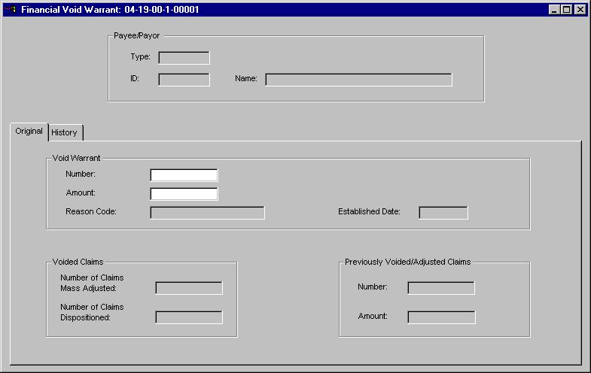

1. Enter the warrant number in the WARRANT NUMBER field and the date in the WARRANT DATE field. Use MM/DD/YYYY format. Enter the amount of the warrant in the AMOUNT field. This field is required. The amount entered here must match the amount of this warrant in the OmniCaid CLAIMS WARRANTDATABASE.
2. In the RELATED FT field, OmniCaid displays the TCN of the CLAIM FINANCIAL TRANSACTION that is created to record the receipt in the Claim Processing Subsystem. The CLAIM FINANCIAL TRANSACTION contains a reimbursement amount equal to the amount of the original warrant and is History Only.
3. If all additions and modifications are complete and you wish to open another selection for this functional group, choose FILE, then SAVE or use the save icon on the TOOLBAR to save your data.
4. If you wish to close this window, use the X icon on the TOOLBAR, or click on the X icon in the right hand corner of the window. Using X icon will result in a confirmation window. Click the YES button to save data and close the window, NO to cancel entry of all data in this session and leave the window open, or CANCEL to cancel the save and closure and continue keying data.

# **Activity #9:**

# Stop Payment-Void Mutilated Warrant:

Description / Purpose

A warrant may be considered damaged or mutilated for one of the following reasons: Damaged during the printing process or returned by the provider who damaged or received a damaged warrant. If the warrant is damaged by Conduent staff during the printing process, the warrant can and should be reprinted, noting the serial numbers of both, so the warrant can be mailed to the provider in a timely manner. If the warrant was returned by the provider, you may reissue the warrant manually or through the system depending on the urgency. System issuances are preferred so that manual handling is limited.

Steps

Procedure 1: Enter Stop Payment

**Financial Specialist:**

From the OmniCaid main screen, click or place cursor on CONTROL PANEL. Drag the cursor until the FINANCIAL selection is highlighted and click. Four choices will appear to the right of Financial. Drag the cursor and highlight and click on RECEIPT. You are now in the FINANCIAL RECEIPT window. Enter the provider number and in the REASON CODE drop down box select – 053 - STOP PAYMENT MUTILATED WARRANT.

1. Enter the warrant amount in the WARRANT AMOUNT field and the warrant date in the WARRANT DATE field use MM/DD/YYYY format. Enter the amount of the warrant in the ORIGINAL AMOUNT field in the Amount group box. This field is required. The amount entered here must match the amount of the warrant in the OmniCaid CLAIMS WARRANT DATABASE.

2. In the RELATED FT field, OmniCaid displays the TCN of the Claim Financial Transaction that is created to record the receipt in the CLAIM PROCESSING SUBSYSTEM. The CLAIM FINANCIAL TRANSACTION contains a reimbursement amount equal to the amount of the original warrant and is History Only.

3. If the warrant is to be replaced, select a radio button in the REPLACEMENT group box to indicate how the warrant is to be replaced.

a. If OmniCaid should generate a replacement warrant, click on the SYSTEM REPLACE radio button.

b. If the warrant is replaced outside OmniCaid, click on the MANUALLY REPLACE radio button, OmniCaid then requires you to enter a WARRANT NUMBER and WARRANT DATE. (This would be a very rare occurrence requiring Financial Manager direction).

4. If all additions and modifications are complete and you wish to open another selection for this functional group, choose FILE, then SAVE or use the save icon on the TOOLBAR to save your data.

5. If you wish to close this window, use the X icon on the TOOLBAR, or click on the X icon in the right hand corner of the window. Using X icon will result in a confirmation window.

6. Click the YES button to save data and close the window, NO to cancel entry of all data in this session and leave the window open, or CANCEL to cancel the save and closure and continue keying data.

7. Print the warrant using EZPay Manager, if needed. The Financial Manager will review the warrant for quality.

8. Prepare logs (Figure 1) for voided and reissued warrants as described in Activity 16.

Figure 1

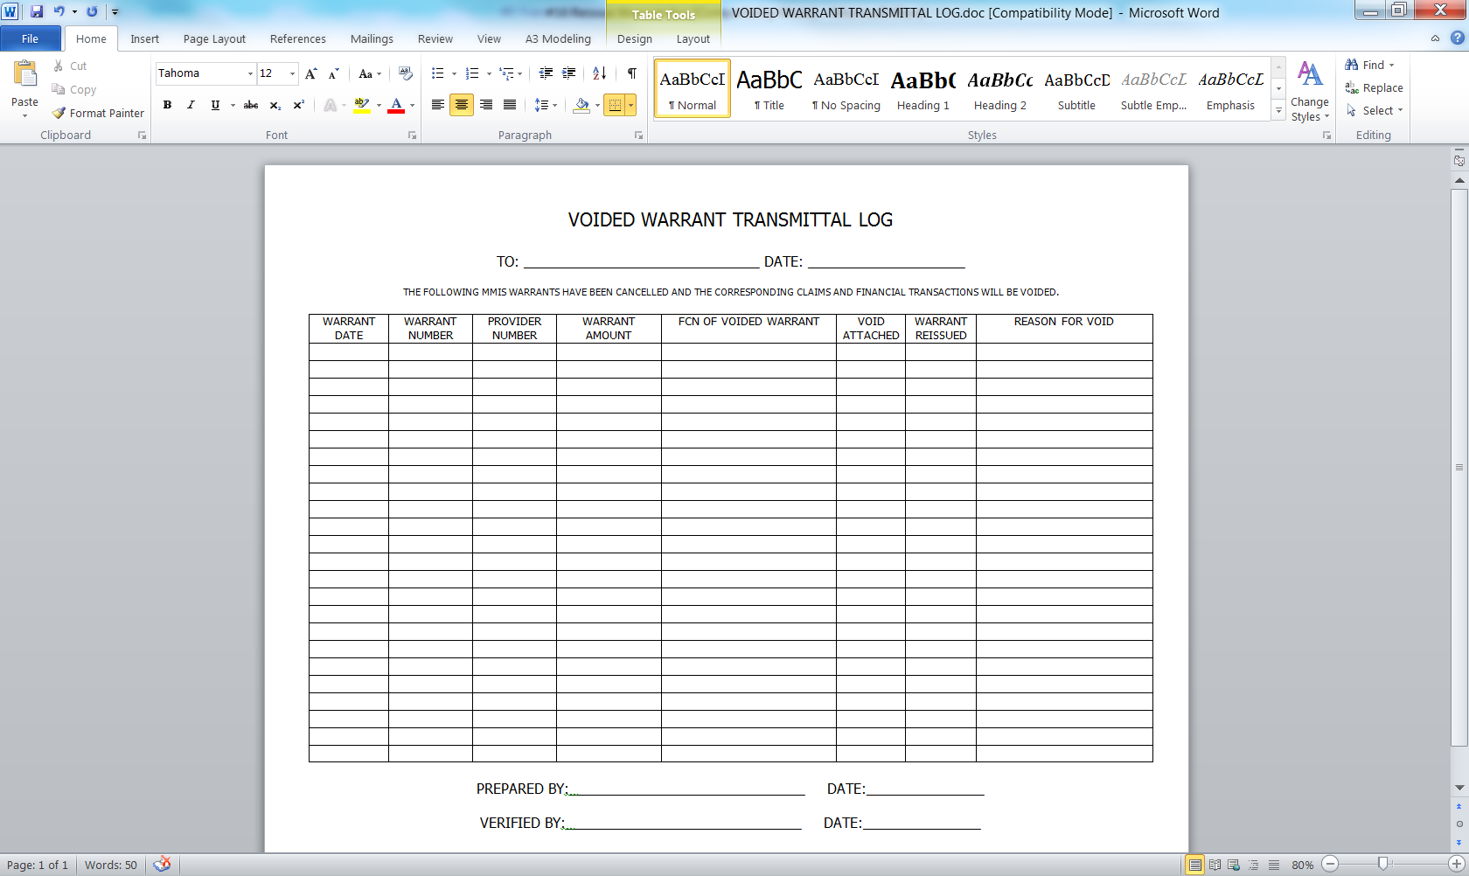

# **Activity #10:**

# Void Warrant-Mass Adjustment:

Description / Purpose

A provider may receive a warrant in payment of claims the provider does not want to keep. The claims may have been submitted using the wrong recipient number or they may have filed the claims but did not provide the service. Regardless of the reason, the provider returns a warrant to Conduent and requests the claims supporting the warrant be voided. This activity may also include warrants returned by the post office as ‘undeliverable as addressed’.

Steps

Procedure 1: Void Warrant and Associated Claims

**Financial Specialist**

Prepare a VOIDED WARRANT TRANSACTION sheet (Figure 1, on next page) for each warrant to be voided.

1. From the OmniCaid main screen, click or place cursor on CONTROL PANEL.  Drag the cursor until the FINANCIAL selection is highlighted and click.  Four choices will appear to the right of FINANCIAL. Click on RECEIPT.  In the RECEIPT screen click on SEARCH BY and enter provider number, click on REASON CODE and it will give you a drop down list of REASON CODES click ‘050 - Stop Payment Return Warrant’. Go to the bottom of the receipt window and select NEW. Another receipt screen will appear to enter the voided warrant information.   Enter the warrant number to be voided in the WARRANT NUMBER box and the amount in the AMOUNT BOX then click SAVE. OmniCaid will automatically assign a FCN number.  OmniCaid voids the warrant and creates a mass adjustment which voids all the claims associated with the warrant.

Note: During the Claims Processing Batch Cycle, OmniCaid updates the VOIDED CLAIMS box with the number of claims mass adjusted. When this number equals the number of claims dispositioned, the void warrant transaction is complete.

1. Prepare log for voided warrants as described in Activity 16.

Figure 1



Figure 2



# **Activity #11:**

# Entering Payout Transactions Into Omnicaid:

Description / Purpose

Payout transactions are payments to providers outside the claims processing system. The primary purpose of a payout is to pay a provider a lump sum for various preauthorized reasons. All payout authorizations are issued by the HSD or the MAD. The payout is transmitted to Conduent on an Accounting Transaction Request (ATR) or, less frequently, on numbered memo. The request must be signed by those authorized from the HSD, MAD and the ASD. It is critical that authorized signatures appear on the ATR. Conduent will periodically be provided memos and updates showing those who are authorized to sign. ATR’s have different presentations depending on the transaction. A sample of a frequently used ATR version is shown as Figure 1 on the next page.

Steps

Procedure 1: Receive and Review Payout ATRs

**Financial Unit Lead or Financial Manager**

1. Receive ATR from HSD (preliminary versions sent via e-mail).

2. Review ATR for critical information necessary to enter the ATR.

3. Review the ATR for authorized signatures (email versions have at least one).

4. If any information is incorrect (including numbering sequence) or missing, contact the designated person at HSD.

Procedure 2: Enter Transactions into OmniCaid

**Financial Unit Lead**

1. From the OmniCaid main screen, click or place cursor on CONTROL PANEL. Drag the cursor until the FINANCIAL selection is highlighted and click. Select PAYOUT. On the SEARCH BY drop down box, select PAYEE/PAYER ID and enter the provider number in the SEARCH FOR box. On the REASON CODE dropdown box, select a reason code corresponding to the type of payout being entered. Click on New. An FCN will automatically be assigned. You are now ready to enter specific payout information. See a sample screen (Figure 2).

2. Enter the amount of the payout.

Figure 1

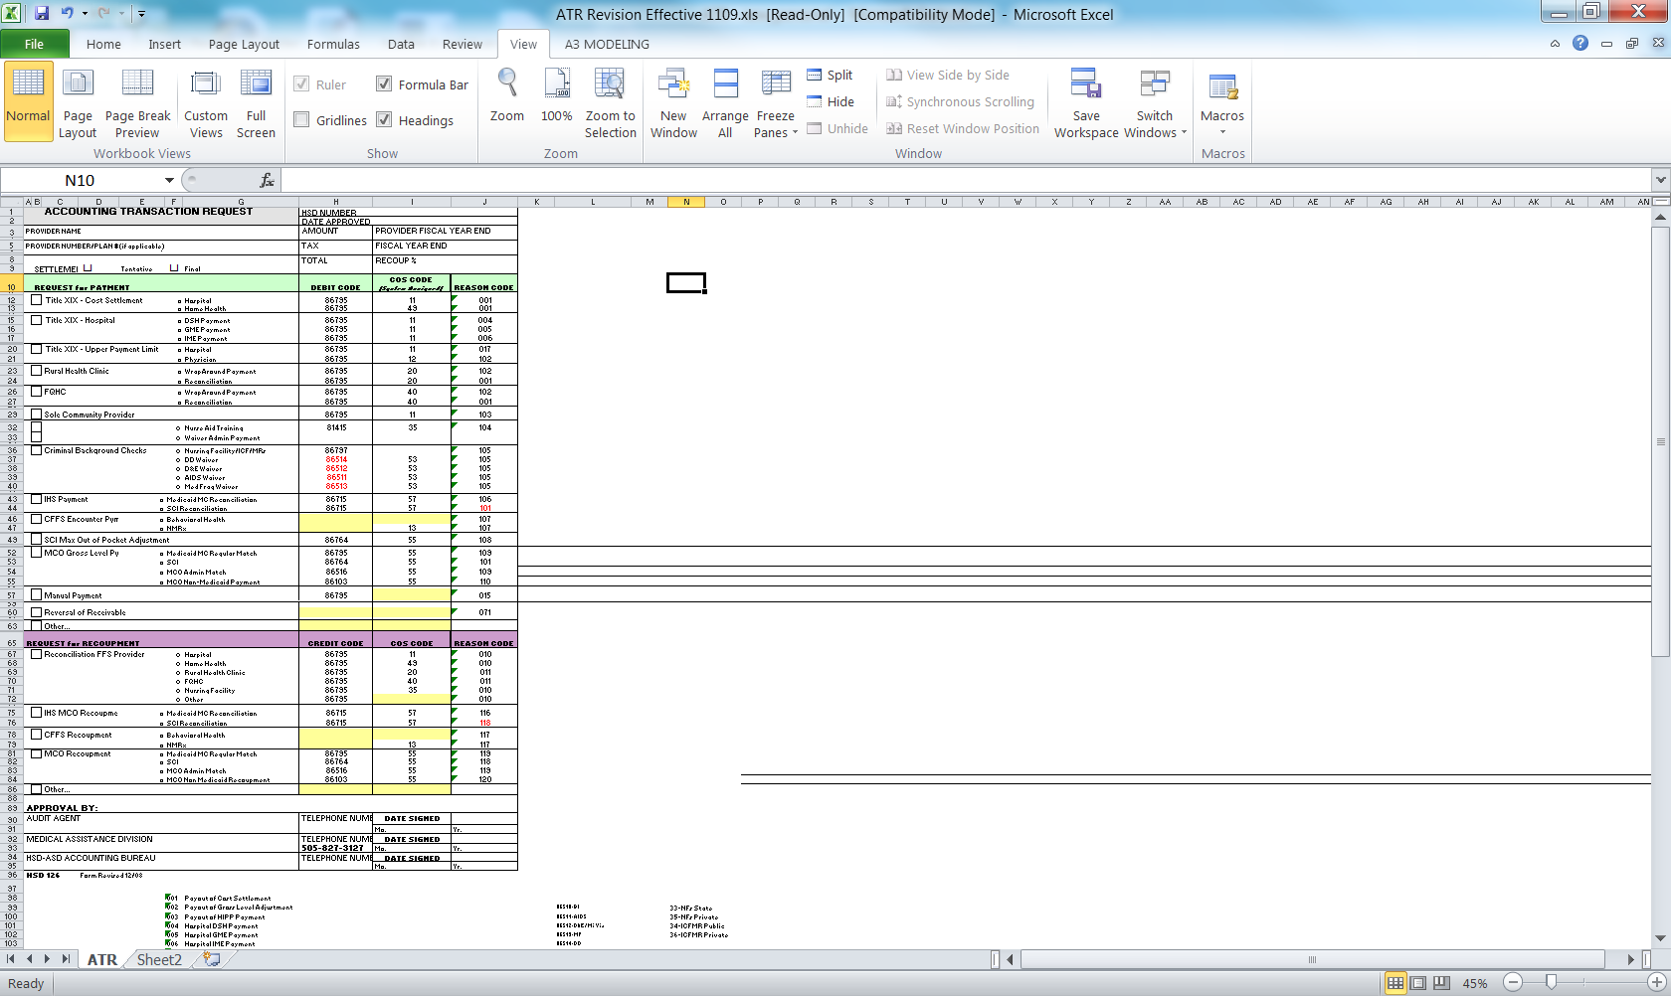

Figure 2

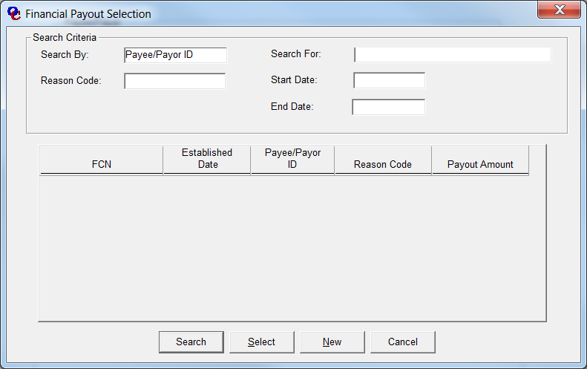

3. If the reason code selected is PAYOUT COST SETTLEMENT, enter the SETTLED THRU Date.

4. Enter the STATE FISCAL YEAR. (MM/DD/YYYY) If you do not enter a date, the system will automatically enter the current fiscal year. (YYYY)This is a required field.

5. Enter the Cost Center. This is a required field.

6. Enter the accounting code if provided.

7. If the information you entered is complete, press F3 or click on the X in the upper right corner of the screen. This will prompt a confirmation window.

8. Click the YES button to save data and close the window. NO to cancel entry of all data in this session and leave the window open, or CANCEL to cancel the save and closure and continue keying data.

9. NOTE: A payout may be modified until the next claims payment cycle runs.

10. NOTE: A payout cannot be deleted. If a payout transaction is entered in error, it can be modified so that it is cancelled before the next payment cycle is run. (To modify, enter .00 in the amount field)

# **Activity #12:**

# Advance Payments:

Description / Purpose

There can at times be a need to issue advances to providers due to unforeseen circumstances which the state deems is a legitimate reason to justify this action. The purpose of an advance payment is to pay a provider for services before the provider’s claims have been processed through claims payment. Because the provider is being paid for claims that are to be processed and paid in the future, the provider owes the amount of the advance payment back to the State. For this reason an advance payment is both a payout to the provider and an accounts receivable amount owed by the provider. An advance payment may be issued manually or by the system in the next payment cycle. Advance payment authorizations are transmitted to Conduent via Accounting Transaction Request (ATR) with appropriate HSD/MAD authorizing signatures.

Steps

**Procedure 1: Receive and Review Advance Payment Request**

**Financial Unit Lead or Financial Unit Manager**

1. Review ATR for completeness.
2. Review ATR for authorized signatures.
3. If the ATR is incomplete or is lacking authorized signatures, call the requester at HSD. Advance payments are critical to the provider so the requester will probably make corrections and fax a new copy of the ATR to Conduent.

**Procedure 2: Enter Advance Payment**

1. From the OmniCaid main screen, click or place cursor on Control Panel. Drag the cursor until the FINANCIAL selection is highlighted and click. Select ACCOUNTS RECEIVABLE. On the SEARCH BY drop down box, select Payee/Payer ID and enter the provider number. Click on NEW. On the REASON CODE drop down box, select the type of advance, either manual or system (015 or 016). An FCN will automatically be assigned. You are now ready to enter specific advance payment information. See the sample screens on the next page.
2. Enter the ORIGINAL AMOUNT.
3. Select a Recoupment choice. This field is required. The three choices are:
   * NO RECOUPMENT-no money will be recouped from the provider.

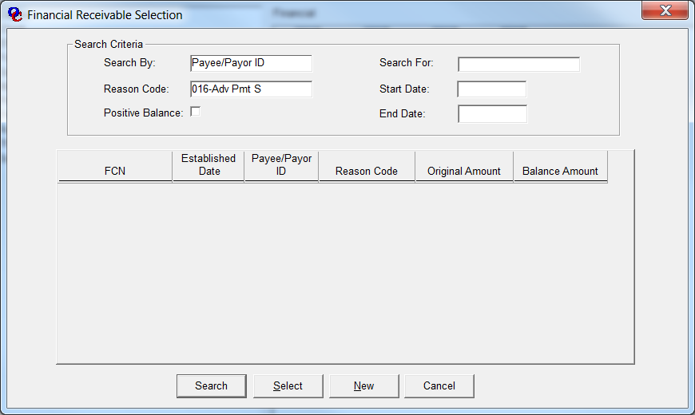

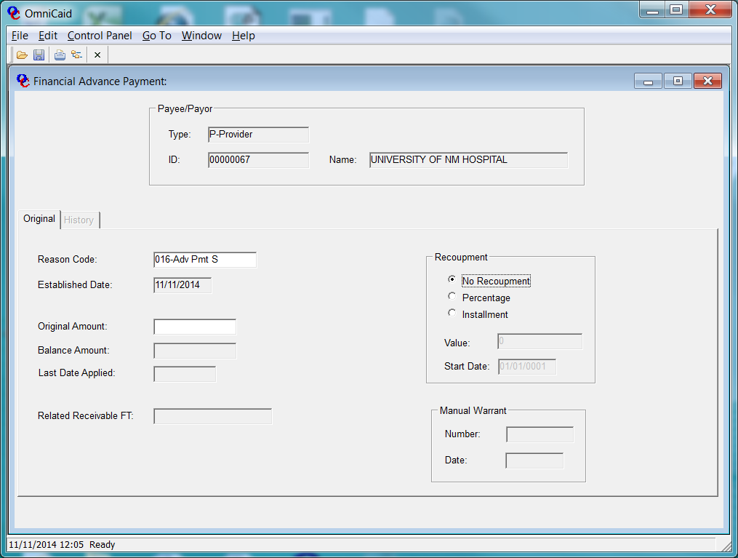

* + PERCENTAGE-Enter the percentage to be recouped in the “Value” box. The system will automatically recoup this percentage from the amount of the provider’s warrant each week until the recoupment is satisfied.
  + INSTALLMENT-Enter the amount of the installment to be recouped from the providers warrant each week until the recoupment is satisfied.
  + If you do not choose a recoupment, the default is 100%. – Note: the choice is usually directed by the state.

1. The start date will automatically be entered by the system.

If you selected MANUAL follow steps 2, 3 and 4 above.

1. Enter the WARRANT NUMBER and DATE.
2. If the information you entered is complete, press F3 or click on the X in the upper right corner of the screen. This will prompt a confirmation window.
3. Click the YES button to save data and close the window. NO to cancel entry of all data in this session and leave the window open, or CANCEL to cancel the save and closure and continue keying data**.**

**Procedure 3: Prepare Manual Warrant**

**Financial Unit Lead**

1. If the selection for the Advance was MANUAL, remove a warrant from the secured warrant room (see Activity #2, Procedure 1).
2. Prepare the warrant in EZPay Manager software as instructed by the ATR.
   * If immediate warrant pick up is needed, notify the ATR requester that the warrant is ready and may be picked up by the provider. Conduent may be asked to facilitate that communication.

# **Activity #13:**

# Gross Level Receivable:

Description / Purpose

MAD may determine that a provider owes the state money for various reasons: due to a Cost Settlement, because of interest owed the State, for Fraud and Abuse, for a SURS Recovery or for a penalty assessed by the State. When MAD determines a provider owes the State money, MAD sends Conduent an ATR (page 31) to initiate the receivable. After the receivable is entered, the balance will be recouped each week as instructed on the ATR.

Steps

**Procedure 1: Receive ATR from MAD**

**Financial Unit Lead or Financial Manager**

1. Receive Receivable ATR.
2. Review ATR for completeness.
3. Review ATR for authorized signatures.
4. If the ATR is incomplete or is lacking authorized signatures, call and advise the requester at MAD. You may be instructed to return the ATR for corrections or signatures.

**Procedure 2: Enter Receivable**

**Financial Unit Lead**

1. From the OmniCaid main screen, click or place cursor on CONTROL PANEL. Drag the cursor until the FINANCIAL selection is highlighted and click. Select ACCOUNTS RECEIVABLE. On the SEARCH BY drop down box, select PAYEE/PAYOR ID and enter the provider number. On the REASON CODE drop down box, select the reason for the receivable. Click on NEW. See the sample screen below. An FCN will automatically be assigned. You are now ready to enter specific receivable information.
2. Enter the “Amount”.
3. Enter the “Cost Center”.
4. Enter the “Accounting Code”.
5. Enter the “FFP Calculate Date”.
6. Enter the “Settlement Thru Date”
7. Select a “Recoupment” choice. The three choices are:

* NO RECOUPMENT-no money will be recouped from the provider.
* PERCENTAGE-Enter the percentage to be recouped in the Value box. The system will automatically recoup this percentage from the amount of the provider’s warrant each week until the recoupment is satisfied.
* INSTALLMENT-Enter the amount of the installment to be recouped from the providers payment each week until the recoupment is satisfied.

1. 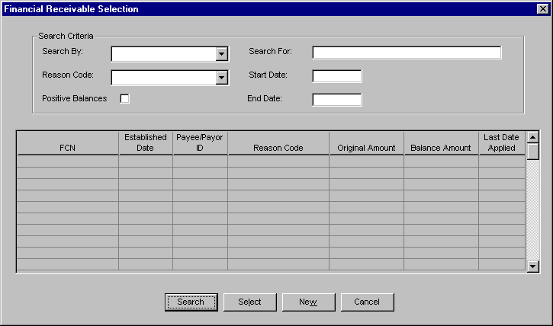If you do not choose a specific recoupment the default is 100%.

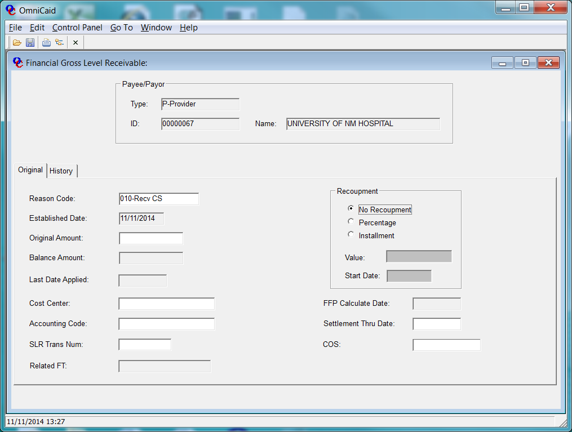

1. If the information you entered is complete, press F3 or click on the X in the upper right corner of the screen. This will prompt a confirmation window. Click the YES button to save data and close the window. NO to cancel entry of all data in this session and leave the window open, or CANCEL to cancel the save and closure and continue keying data.

# **Activity #14:**

# Receivable Transfer:

Description / Purpose

MAD may determine that a receivable balance should be transferred from one provider to another provider. This could be due to a change of ownership or the provider may be inactive under one number and request the receivable be transferred to their active number. MAD sends a Receivable Transfer to Conduent on an ATR.

Steps

**Procedure 1: Receive Receivable Transfer**

**Financial Unit Lead**

1. Receive ATR or numbered memo from MAD for receivable transfer.

2. Review ATR for completeness.

3. Review ATR for authorized signatures.

1. If the ATR is incomplete or is lacking authorized signatures, call the requester at MAD. You may be instructed to return the ATR for corrections or signatures.

**Procedure 2: Enter Receivable Transfer**

**Financial Unit Lead**

1. Determine the Financial Control Number (FCN) for the receivable to be transferred.
2. From the OmniCaid main screen, click or place cursor on CONTROL PANEL.  Drag the cursor and select FINANCIAL.  Select ACCOUNTS RECEIVABLE.  You are now ready to enter specific receivable transfer information.  See the sample screen on next page.
3. On the SEARCH BY drop down box, select FCN and in the SEARCH FOR box enter the Financial Control Number for the original receivable from step 1. Click on REASON CODE and select 098-Receivable Transfer from the drop down, click on the NEW button at the bottom of the screen and that will take you to the screen to execute the transfer.
4. Enter the provider number of the provider the receivable is to be transferred to.
5. When the information you entered is complete, click on the x in the upper right hand corner then confirm that the change is to be saved.  NO to cancel entry of all data in this session and leave the window open, or CANCEL to cancel the save and closure and continue keying data.

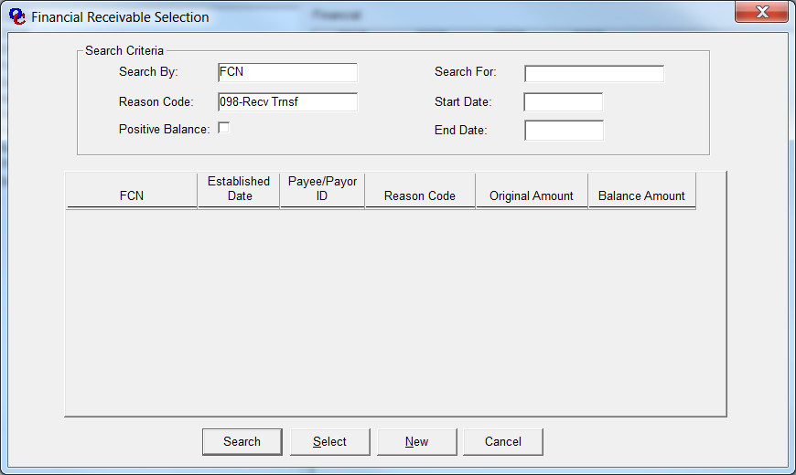

**20140818-1-000073**

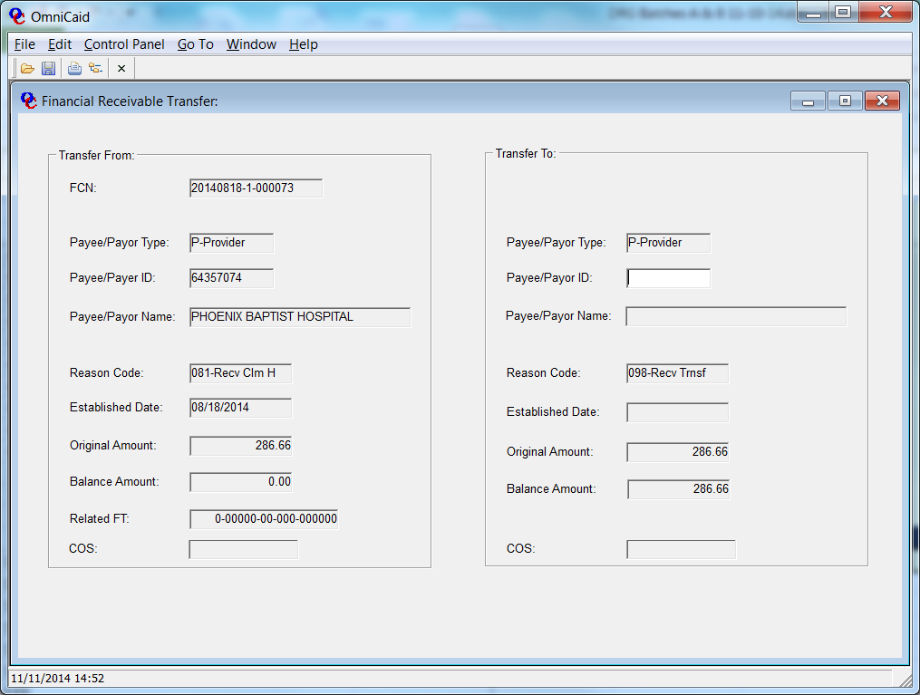

# **Activity #15:**

# Receivable Reversal:

Description / Purpose

MAD may determine that a receivable needs to be reversed (terminated or corrected). MAD can reverse a receivable by sending Conduent an ATR.

Steps

**Procedure 1: Receive Reversal ATR**

**Financial Unit Lead**

1. Receive ATR or numbered memo from MAD for receivable reversal.

2. Review ATR for completeness.

3. Review ATR for authorized signatures.

4. If the ATR is incomplete or is lacking authorized signatures, call the requester at MAD. You may be instructed to return the ATR for corrections or signatures

**Procedure 2: Enter Receivable Reversal**

**Financial Unit Lead**

1. Determine the Financial Control Number (FCN) for the receivable to be reversed.
2. From the OmniCaid main screen, click or place cursor on CONTROL PANEL.  Drag the cursor and select FINANCIAL.  Select ACCOUNTS RECEIVABLE.  You are now ready to enter specific receivable reversal information.  See the sample screen on next page.
3. On the SEARCH BY drop down box, select FCN and in the SEARCH FOR box enter the Financial Control Number for the original receivable from step 1. Click on REASON CODE and select 071-Receivable Reversal from the drop down, click on the NEW button at the bottom of the screen and and SAVE to execute the reversal.

4. Update only the COST CODE or ACCOUNTING CODE. The system automatically updates the remaining fields and sets the receivable balance to zero.

* If the information you entered is complete, press F3 or click on the X in the upper right corner of the screen. This will prompt a confirmation window.

3. Click the YES button to save data and close the window. NO to cancel entry of all data in this session and leave the window open, or CANCEL to cancel the save and closure and continue keying data.

# 

# **Activity #16:**

# Reissue Warrant:

Description / Purpose

If a warrant has been lost or stolen, the provider completes an affidavit. The affidavit is forwarded to ASD/HSD. If the bank has paid the warrant, ASD mails the provider a copy of the warrant. If the warrant has not been paid, ASD places a stop payment with the State Treasurer’s Office and sends Conduent Financial Unit an authorization for replacement. The Financial Unit voids the warrant in Omnicaid and issues a replacement warrant.

If a provider contacts Conduent concerning a lost warrant, they must be advised to wait three weeks to see if they receive the warrant. If the provider won’t accept the three-week waiting period, or if the warrant is of a significant amount, call ASD and to request an exception.

If a warrant has been destroyed in the printing and/or signing process, a replacement warrant is also prepared. In this case, however, the Financial Unit initiates the replacement warrant via EZPay Manager and only the old and new document serial numbers are tracked, since the same warrant number is used.

Steps

**Procedure 1: Affidavit Process**

**Financial Specialist**

Below (Figure 1) is an image of the Affidavit form that must first be completed and submitted to ASD/HSD, either directly by the provider or through the Conduent Financial Unit.

**Procedure 2: Receive Authorization For Replacement Warrant**

**Financial Specialist**

1. Receive the authorization for replacement from ASD, which is typically a form letter containing the pertinent information.
2. If the replacement is initiated by an authorization from ASD, obtain a copy of the Remittance Advice from Intraviewer. If the replacement is because the warrant was damaged in the printing/preparation process, stamp VOID on the mutilated warrant and recreate it in EZPay Manager and record document serial numbers for both.

Figure 1.

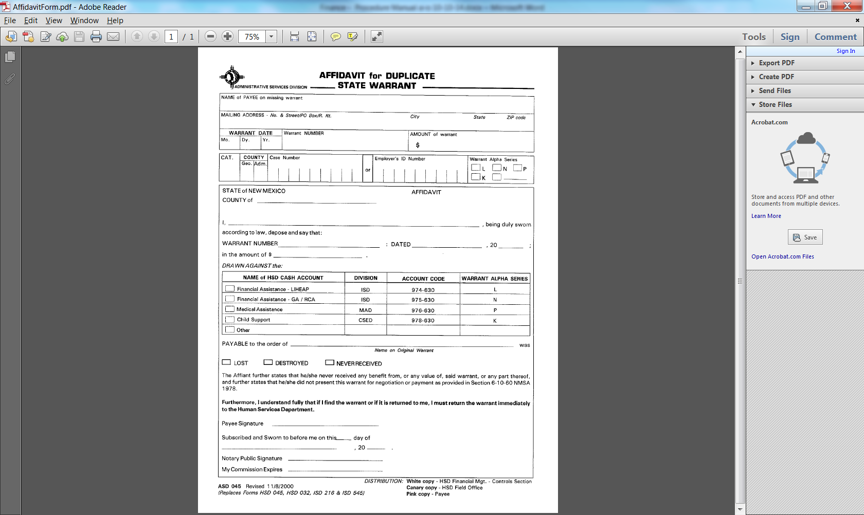

**Procedure 3: Complete a VOID WARRANT TRANSACTION LOG**

**Financial Specialist**

1. Log the original warrant on the VOIDED WARRANT TRANSMITTAL LOG (Activity 9, page 26). Attach the authorization from ASD or a copy of the damaged warrant to the VOID WARRANT TRANSACTION LOG.
2. Complete a MANUAL WARRANT LOG. (Figure 2 below)

**Note: When preparing a re-issued warrant, the replacement warrant must always equal the amount of the original warrant.**

Figure 2

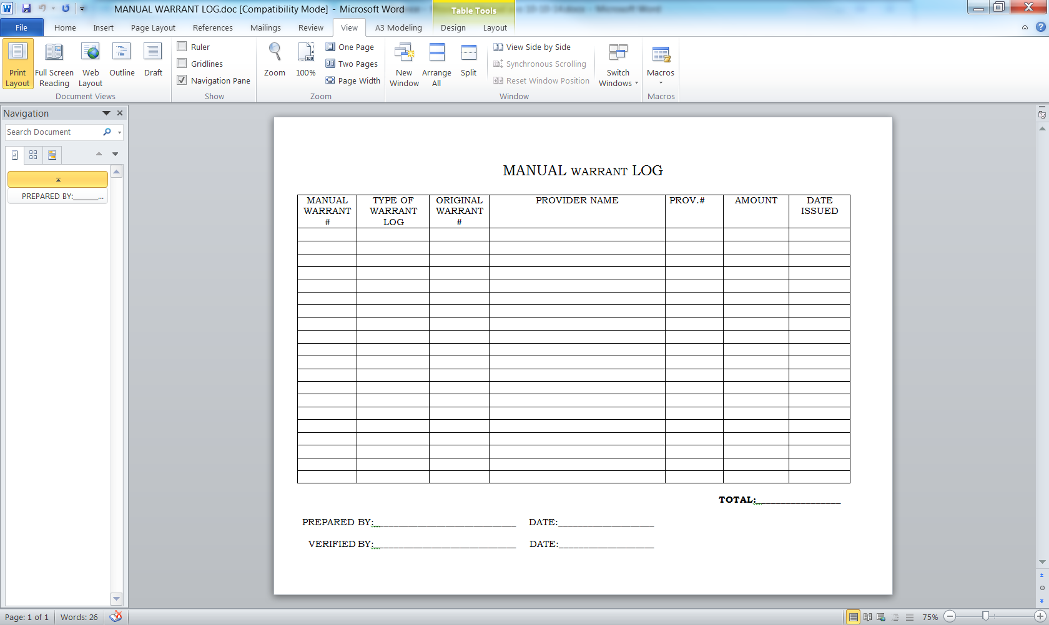

**Procedure 4: Prepare Manual Warrant**

**Financial Unit Lead or Financial Manager**

1. Follow the procedures described in Activity 2 for removing warrants from secured storage.
2. Prepare the manual warrant with the EZPay software using the information from the Affidavit or the MANUAL WARRANT LOG.
3. Each warrant must be reviewed and approved by the Conduent Financial Unit Manager.
4. Prepare and mail the manual warrant with a copy of the Remittance Advice to the provider.
5. Make photo copy of the replacement warrant.
6. Forward two copies of the replacement warrant and and one copy of the MANUAL WARRANT LOG to ASD.
7. Enter the void and reissued warrant into the Financial Subsystem using the appropriate screen for voided warrant as described in Activity 9.
8. Retain a copy of the logs and warrant in the Financial Unit files.

# **Activity #17:**

# Receivable Refund From Provider:

Description / Purpose

A provider may be made aware of a receivable balance he owes the state by reviewing their Remittance Advice or by being notified by the Conduent Financial Unit.

The provider may choose to send Conduent a check to cover the receivable balance.

Steps

**Procedure 1: Receive Refund**

**Financial Specialist**

1. Receive the refund from the provider (review Activity 5)
2. Review provider file to verify receivable.
3. Send the check to ASD and record on a REFUND CHECK TRANSMITTAL LOG.

**Procedure 2: Enter Transaction into Omnicaid**

1. Follow instructions in Activity 5, 6, & 7, as applicable.

# **Activity #18:**

# Prepare Void Adjustment Batches

Description / Purpose

Before adjustments or voids can be entered in OmniCaid they must be batched. A batch is a group of no more than 50 adjustments or voids. The batch is prepared by the Financial Unit and forwarded to Claims Processing Unit to be imaged. The purpose of imaging is to assign each adjustment or void a unique transaction control number (TCN).

Steps

**Procedure 1: Prepare Adjustments and Voids for Batching**

**Financial Specialist**

1. Separate adjustments and voids into two groups to be batched separately.
2. A batch cannot exceed 50 adjustments or voids.

**Procedure 2: Complete Batch Cover Sheet**

**Financial Specialist**

1. Complete a BATCH COVER SHEET (Figure 1) for each group of 50.
2. Enter the number of documents, the medium (always 8), the batch julian date and the batch number. The range of batch numbers for financial is 700 thru 775. The first batch would be 700 the second batch 701 etc.
3. Enter your name and special instructions if appropriate.
4. Forward batches to the scanning room. The batch is prepared by the Financial Unit and forwarded to Claims Processing Unit to be imaged. The purpose of imaging is to assign each adjustment or void a unique transaction control number (TCN).
5. After batches have been scanned they will be forwarded to Claims Resolution Unit for exam entry.

**NOTE: IT IS VERY IMPORTANT TO INDICATE ON THE BATCH COVER SHEET THAT THESE ARE FINANCIAL TRANSACTIONS AND THEY MUST BE ENTERED AS HISTORY ONLY. IT IS EVEN A GOOD IDEA TO PUT A FIRST SHEET INSIDE THE BATCH INDICATING IT IS HISTORY ONLY.**

Figue 1

CSD

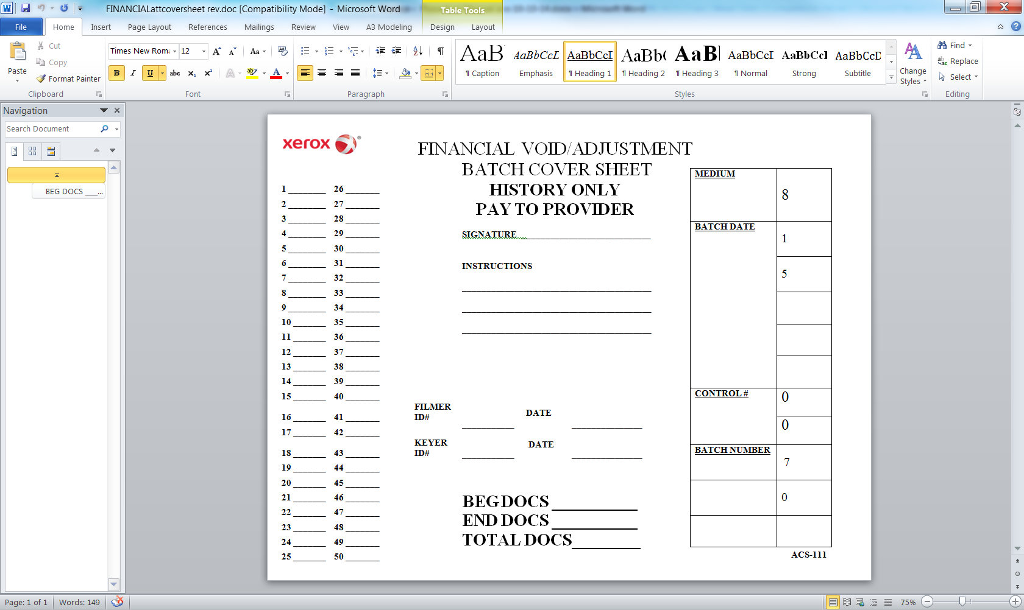

# 

# **Activity #19:**

# Securing Postage For Client Mailings

# Description / Purpose

Conduent must provide postage, reimbursable by the state, for various program related mailings. Adequate time must be allowed to acquire postage checks from Conduent’ accounts payable system so that permit balances do not fall below levels that will cause delays in mailing any items. Monitoring of permit balances, changes in mail volume and status of submitted check requests are keys to smooth operation of monthly mailing functions by the outside vendor(s).

Steps

**General Information:**

Conduent uses the corporate accounts payable system to periodically acquire postage checks made out to the United States Postal Service. The checks are treated as prepaid (balance sheet level) expenses and only the actual postage used, based on monthly USPS postage reports, is shown as account level expenses for the respective month.

Most of this postage is used by the mailing vendor charged with sending out monthly client notices for enrollments, reminders, notifications, confirmations, terminations and other notices. Close communication with vendor is required to monitor quantities especially when changes impact volumes and postage requirements. This postage process is also used to acquire postage for the Business Reply Mail through a BRM account at the USPS.

1. Determine pattern of postage use for each permit imprint, business reply mail account and vendor meters [current postage accounts include: meters at vendor site - Postage by Phone account #47721733, Permit Imprint 1137 used by mailing vendor when the indicia is preprinted on envelopes, and BRM 5003 for prepaid return envelopes] by reviewing account activity reports provided monthly by the postal service and the vendor for their meter activity. The Conduent mailroom also uses meters for which they monitor and obtain postage. Copies of usage reports are kept with each monthly state invoice as they are used to bill the state for postage used.
2. To obtain additional postage, or fee payments, fill out and send a check request form per the example (see Figure 1). (Form is in the Shared drive under Finance/Postage Forms). Currently for postage the Company Code is 27100, Cost Center is 27103200, the G/L Account (prepaid) is 14130.105 (Tip: requests exceeding $50,000 require additional Regional level approvals adding to the time necessary to complete the process). For fees: Company Code 27100, Cost Center 27103200, G/L Account 52650. The form must be signed by the preparer, who also should be an authorized coder in the Conduent AP Workflow system, and by the approver, who should be authorized in AP Workflow to approve the dollar amount requested for the cost center specified. Request will appear in APW for coding per APW rules.

**Figure 1** CSD 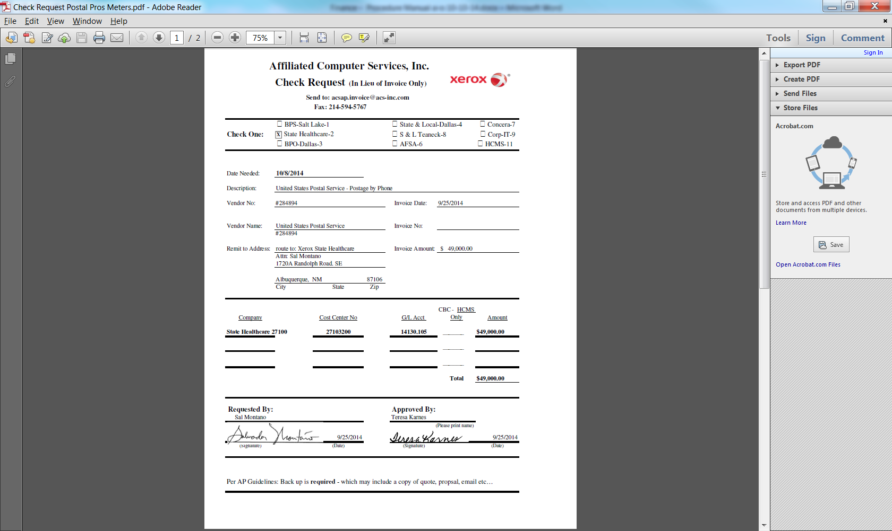

1. Also, fill out and send an Accounts Payable Return Checks Form (Figure 2) in order to have the check delivered via express carrier to the local Conduent office. (Form is in the Shared drive under Finance/Postage Forms).

Figure 2

CSD

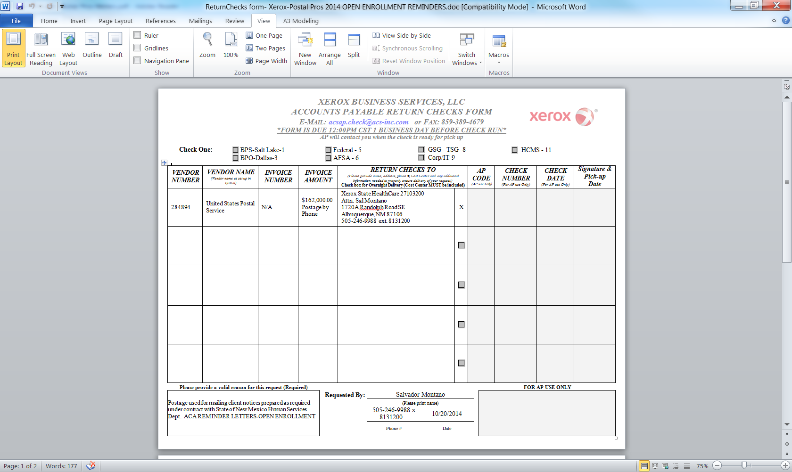

1. Each of the forms should be emailed or faxed using the contact information shown on the forms. If needed, assistance is available by submitting a request to the email addresses on the respective forms.
2. When the check is received:
3. For BRM permit, or permit imprint accounts - hand deliver it to the United States Post Office and have it deposited to the permit where funds are needed. The USPS, in some situations, does allow apportioning one check to multiple Conduent permits (or annual fees that may be due) if that is desired.
4. For mailing vendor meters – send check by express delivery to:

Reserve Account

ATTN: Box 223648

Suite 154-0460

500 Ross Street

Pittsburgh, PA 15262-0001

*(Example of a Table)*

|  |  |  |  |
| --- | --- | --- | --- |
| Table Fonts | Table Font | Table Font | Table Font |
|  |  |  |  |

# Appendix:

*(This area is used for any necessary supplemental documents or tools that are used in the department i.e charts, hyperlinks etc. There can be more than one Appendix and each is identified by a letter ie A, B, C, etc.).*